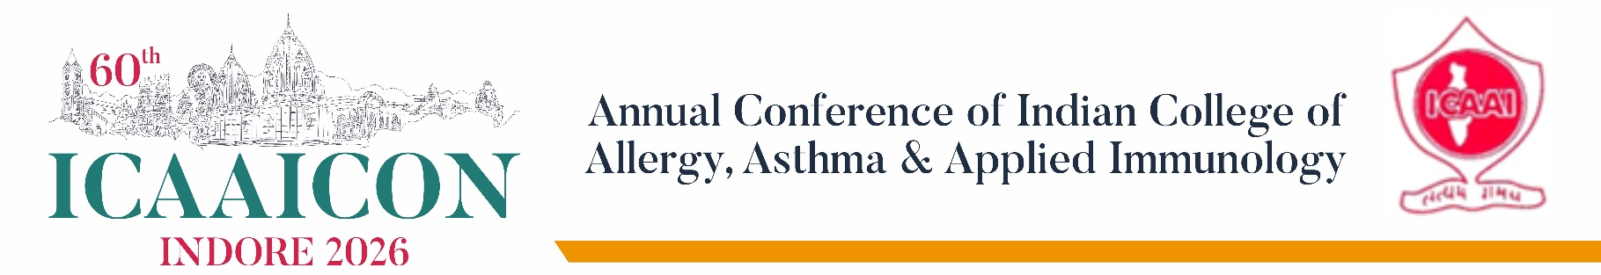

Sponsorship Benefits

Platinum Sponsor – ₹10 Lakhs
- Premium exhibition stall
- Exclusive Platinum Sponsorship status (allocated on a first-come, first-served basis)
- Prominent branding across all promotional materials and the official conference website
- Logo and company profile featured under the Platinum Sponsor category on the official Sponsor Panel
- Inclusion of promotional materials in the Delegate Kit
- Branding on participant badges

Diamond Sponsor – ₹8 Lakhs
- Premium exhibition stall
- High-visibility branding opportunities
- Logo and company profile featured under the Diamond Sponsor category on the Sponsor Panel
- Inclusion of promotional materials in the Delegate Kit

Gold Sponsor – ₹6 Lakhs
- Exhibition stall
- Recognition as a Gold Sponsor on the conference website
- Logo and company profile featured under the Gold Sponsor category on the Sponsor Panel
- Inclusion of promotional materials in the Delegate Kit

Silver Sponsor – ₹4 Lakhs
- Exhibition stall
- Recognition as a Silver Sponsor on the conference website
- Logo and company profile featured under the Silver Sponsor category on the Sponsor Panel

Regular Stall – ₹2 Lakhs
- Standard exhibition stall

Note
GST @ 18% will be applicable on all sponsorship and exhibition categories.

